**CSE445/598 Assignment/Project 3 (100 Points) Summer 2016**

Part 1 Due by 11:59pm of June 11, 2016, in Blackboard

Part 2 Due by 11:59pm of June 18, 2016, in WebStrar Server and in Blackboard

# Introduction

The aim of this assignment is to make sure that you understand and are familiar with the concepts covered in the lectures, including service development, service registration, service deployment, service hosting, service proxy, service binding, service invocation, and application building using your own services and public services. By the end of the assignment, you should have applied these concepts in programming your services, deploying your services, and have used your own services and public services to compose your SOC applications.

This project is an **individual project**. No cooperation of any kind is allowed. The final project must be deployed into the given Web server: WebStrar. When submitting the services and service test pages into the blackboard, you must submit the folder (folders) with the source code (We will read the source code from Blackboard and test the code from the server). For the server deployment, you can submit folders with the source code or with the precompiled files in the folder.

# Section I Practice Exercises (No submission required)

No submission is required for this part of exercises. However, doing these exercises can help you better understand the concepts and thus help you in quizzes, exams, as well as the assignment questions.

1. Reading: Textbook Chapter 3 and Appendix C.
2. Answer the multiple choice questions 1.1 through 1.16 of the text section 3.10. Study the material covered in these questions can help you prepare for the class exercises, quizzes, and the exams. Answer keys to the questions can be found in the course web page. To better learn these concepts, you should do the exercises based on your understanding, and then check the answer keys.
3. Study for the questions 2 through 16 in text section 3.10. Make sure that you understand these questions and can briefly answer these questions. Study the material covered in these questions can help you prepare for tests and understand the homework assignment.
4. Questions 17 through 19 are largely covered by the assignment questions in Part II.

# Section II Assignment/Project Questions (Submission required for all students)

The purpose of this project is to exercise service development, service deployment, service discovery, remote binding, and application composition using your own services and external public services. Some of the services to be developed can be synthetic, e.g., banking service, while others can be realistic, e.g., en/decoding, en/decryption, and product catalog. However, you should make your services and overall application as realistic as possible. The project will be completed in following parts.

## Part 1 Requirement Document [50 points]

1. The requirement document will contain the following contents.
   1. Description of the service-oriented computing system that you plan to develop. [2]

I plan to develop two different services one will take a video id and search all of youtube for it. If the video is found it will display the title of the video along with the description. Google API key should be valid at testing time so the code will work with my Key for another week or so.

My other service will be a weather service that will display the 5 day forecast of a given zip code along with some art work of the weather. The service use a yahoo API. !THIS API MAY NOT BE ACTIVE ON TEST DATE! IF NOT YOU CAN ENTER YOUR OWN IF YOU DON’T MIND, setting file set up for an easy entry of api key.

* 1. A diagram showing the overall system design, its layers, components, and the connections among the services. A sample diagram is given in Figure 1. You must come up with your own system. You will not implement the application logic layer of system outlined here in this assignment. It will be implemented in assignment 5. The focus of this assignment is to develop and deploy the **services** outlined in this requirement document. Thus you must pay more attention to the services in this

assignment. [2]

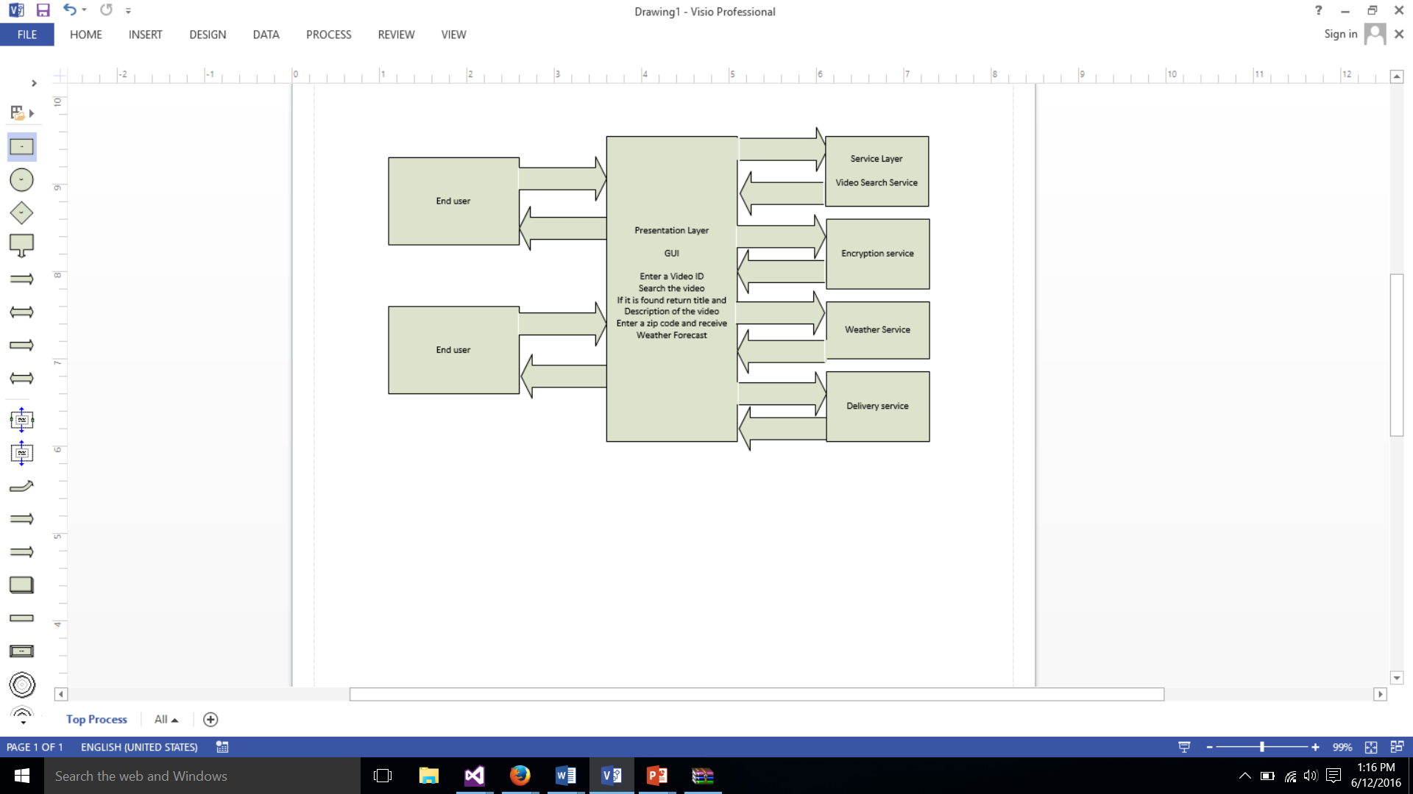

**Figure 1**. A sample of a four-tier service-oriented computing system

* 1. Create a service directory (a table) listing the services that you plan to develop. You must list three to five services in this table. Each service must be described in such detail that shows the feasibility of implementing the service in a reasonable amount of time, e.g., 10 hours. All the services must be related to the application that you outlined in the question above and support the composition of the application. The contents of the table below are examples, and you need fill the table based on your

own work plan. [6]

|  |  |  |  |  |
| --- | --- | --- | --- | --- |
| This page is deployed at: Fill out the URL in Part 2 submission. | | | | |
| This project is developed by: Matthew Kirt-Dunning | | | | |
| Provider name | Service name, with input and output types | TryIt link | Service description | Planned resources need to implement the service |
| matthew dunning | Encryption and decryption: Input: String  Output: String | In code | Cipher encryption and decryption | Use library class and local component to implement the service |
| Matthew  dunning | YouTube API custom  Input: string of youtube video id  OutPut: string title of video and string description of video | In Code solution  Local host provided there as well | Upon getting a video id it will search the video and return detailed information about it | Use the YouTube API to search for a video and return information |
| Matthew  Dunning | Weather  Input: integer Output: forecast | In studio  Solution local host provided there as well | Takes a zip code and returns the weather forecast | Service hosted by yahoo api |

1. You must implement a set of services in this assignment. There are two types of services to be developed: required services and elective services. The required services will be developed in this question and the elective services will be developed in Part 2 of this assignment.

## 2.1 Required Services [30 = 15+15]

A set of required services and their requirements are listed in a separate document named “List of Required Services”. You must choose and implement **two** services from the given list. For the elective services in the next section, you will be asked to develop at least one RESTful service.

## 2.2 TryIt Pages of the Required Services [10]

For each service and operation that you developed, you must develop a TryIt test page to allow the human user to test the service. The TryIt test page must contain the following contents:

1. A sentence to describe the functions of each service (operation);
2. The URL of the service
   1. For Part 1 submission: use the Localhost URL of the WSDL file.
   2. For the final submission in Part 2, the service URL of each service (or its WSDL address) must be used in the TryIt page must be the URL in the server. No localhost address can be used. For the required services, you will develop WSDL/SOAP services.
3. Method names, with parameter type list and the return type for each endpoint.
4. Text boxes for entering inputs
5. Invoke buttons to call the services
6. a place (e.g., label) to display the service response (output)

The two services and the TryIt page will be tested on the localhost in part 1 submission. To make sure the TA can test your services and TryIt pages on their computer, you must specify the localhost port number statically follow the Set Up Static Port Number in the PPT file.

You can combine the test pages of multiple services and operations into one test page. You must make sure that you have a GUI to test every service operation that you developed for credit. An example of 3.E, 3.F, and 3.G is given in the figure and in the link below:

<http://venus.eas.asu.edu/wsrepository/Services/FileServiceTryIt/>

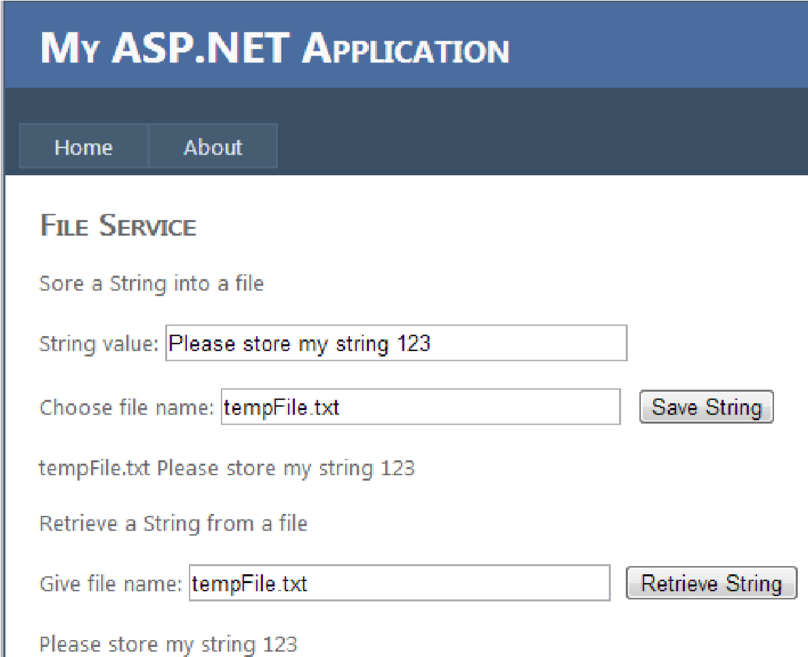

More examples of TryIt test page are at: <http://venus.eas.asu.edu/WSRepository/AjaxIn/Default.aspx>

<http://venus.eas.asu.edu/WSRepository/Services/ImageVerifier/Tryit.aspx> <http://venus.eas.asu.edu/WSRepository/Services/RandomString/Tryit.aspx> **Part 2 Elective Services Development [50 points]**

You must submit a single zip file into Blackboard. The zip file must contain all the **elective services** and their TryIt pages developed in this part of the assignment. All the services (required and electives) must be deployed into the WebStrar server.

1. In this part, you will develop the elective services and their TryIt pages.

3.1 **Elective Services**: You must develop at least two elective services (or service operations). The elective services must be related to the application defined in question 1. At least one service must be converted to the RESTful service. For the rest of the services, you can choose to develop WSDL services or RESTful services. For developing RESTful service, please follow Lecture Slides L10 or

textbook section 7.3.3.2. **[25 points for 3.1]**

The difficulty level of the elective services (operations) that you developed will be rated by the instructor and the teaching assistant into one of the three difficulty levels:

* 1. Easy: The method (operation) in this service implements a simple math function and can be done using less than 50 lines of code, for example, Fahrenheit and Celsius temperature conversion. [5 points each]
  2. Moderate: There are algorithmic issues to address and the code for each method will be at least 50 lines, for example, encryption/decryption service, efficient sorting, and equation system solving. If a service operation can be done in less than 50 lines, but you use more than 50 lines, it will be

counted as an easy service. [10 points each]

* 1. Challenging: Services that will use states, such as creating a simulated (synthetic) banking service that allows users to sign up, create an account, deposit fund, spend fund, etc.; or services that make use of multiple available services (operations) or APIs provided by other providers, such as Microsoft services (e.g., Bing map service), Google code’s APIs, Amazon’s services, or the ASU services. These services and APIs may or may not have WSDL interface. Your services must provide WSDL interfaces. The data received from other services should be processed and combined before returning to the clients. The given required services are examples of challenging services: If you choose to implement these services, they count as challenging services. Database is not allowed in this assignment. If you need to store states, you can either a text file (See Chapter 3 L12 Slides) or an XML file (Read Text Chapter 4 and also Chapter 5, Section 5.4). [15 each]

To obtain the full points in question 3.1, you need to develop at least two services and at most four services. It implies that you cannot write five easy services in this question. If you write easy services only, the maximum points you can obtain in this question is 20. On the other hand, you can obtain 25 points at most, even if you develop more services and more difficult services than required. From the format point of view, you can either define these services methods in one big service, or define them as separate services. Each service and methods must be commented in detail, including the functionality, parameters, types, and the return value type.

## 3.2 Development of TryIt Pages for Elective Services [5 points for 3.2]

You must develop TryIt test page for elective services. The requirement is the same as defined in question 2.2, but all the URLs must be based on the server URLs because the services have been deployed to the server. You must also have the URL of the Main page (See next question) linked to the test pages, so that one can return to the main page from the TryIt page.

## 3.3 Deployment of Required Services, Elective Services, and TryIt pages [5 points for 3.3]

All the services (required and elective) and their TryIt pages must be deployed into WebStrar server. You must deploy the services first. Before deploying the TryIt pages, you must change all the service references from localhost addresses to the server addresses, so that the services can be tested from the server.

1. The main page must be an html page. The main page must be named index.html, so that the page can be accessed through the link: [http://webstrarX.fulton.asu.edu/index.html,](http://webstrarx.fulton.asu.edu/index.html) where X is your site number. The main page must contain the following contents:

4.1 Service directory (a table) listing the services and links to the test pages (TryIt pages) and services. The schema and a list of example services are shown in the table below, which is similar to the table in the requirement document, except that the TryIt pages must be linked into the page. [8]

|  |  |  |  |  |
| --- | --- | --- | --- | --- |
| This page is deployed at: [http://webstrarX.fulton.asu.edu/index.html](http://webstrarx.fulton.asu.edu/index.html) (change X to you site number) | | | | |
| This project is developed by: Put your team name here. | | | | |
| Provider name | Service name, with input and output types | TryIt link | Service description | Actual resources used to implement the service |
| Your name | Encryption and decryption: Input: String  Output: String | TryIt | Cipher encryption and decryption | Use library class and local component to implement the service |
| Your name | SolarPower  Inputs: zip code and size Output: integer | TryIt | Output annual KW number for a given panel size at a given zip code location | Retrieve information from national database at:  <http://graphical.weather.gov/xml/> |
| Your name | findStore Input: zipcode Output: list of string | TryIt | Use an existing online service or API to find the locations of a given store name | Use the service from Yelp site at:  http://www.yelp.com/ |
| … | … |  | … | … |
| Your name | textToPhone inputs:  string Account, string Password, string Receiver, string Subject, string Body Output: boolean | TryIt | Send a text to a cell phone and return if the message is sent successfully | Use google gmail account and carrier services:  phone_number@tmomail.net phone_number@messaging.sprin tpcs.com  phone_number@vtext.com phone_number@txt.att.net |
| … | … |  | … | … |

Make sure that you have the deployment URL in the first row of the page!

4.3 Deploy the table in html into WebStrar server, in the root directory outside the pre-created directories, so that the page can be accessed using the address: [7 points] [http://webstrarX.fulton.asu.edu/index.html](http://webstrarx.fulton.asu.edu/index.html) (change X to you site number)

This page must also be submitted into Blackboard.

# Submission Requirement

All submissions must be electronically submitted to the assignment folder where you downloaded the assignment paper. The entire solution with all the files must be zipped into a single file.

If you have saved a project/Website in a different folder, you can copy the folder containing the project/Website to the directory where the other projects are saved. Then go into Visual Studio and delete the project/website that was in a different place. Then right click the solution in Visual Studio and add existing project/website, browse to the new location and select the project/website to link the moved project/website into the solution.

Submission preparation notice: The assignment consists of multiple **distributed** projects and components. They may be stored in different locations on your computer when you create them. You must copy these projects into a single folder for blackboard submission. To make sure that you have all the files included in the zip file and they work together, you must test them before submission. You must also download your own submission from the blackboard. Unzip the file on a different location or machine, and test your assignment and see if you can run the solution in a different location, because the TA will test your application on a different machine.

# Grading

We will grade your programs following these steps:

1. We will read your program and give points based on the points allocated to each component, the readability of your code (organization of the code and comments), logic, inclusion of the required functions, and correctness of the implementations of each function.
2. Compile the code. If it does not compile, 40% of the points given in (1) will be deducted. For example, if you are given 20 points in step (1), your points will become 12 if the program fails to compile.
3. If the code passes the compilation, we will execute and test the code. If, for any reason, the program gives an incorrect output or crashes for any input, 20% of the points given in (1) will be deducted.

Please notice that we will not debug your program to figure out how big or how small the error is. You may lose 40% or 20% of your points for a small error such missing a comma or a space!

# Late submission deduction policy:

• No penalty for late submissions that are received within 24 hours of the given deadline; • 2% grade deduction for every hour after the first 24 hours! No submission after Monday.